1. Identify Spending Power by Education
Does a higher degree mean higher spending in this dataset?

select Education_Level,avg(Purchase_Amount) as Avg_Spend,COUNT(Customer_ID) as Count_Of_Customer from dbo.[Ecommerce_Consumer_Behavior_Analysis_Data after data cleaning] group by Education_Level order by avg(Purchase_Amount)
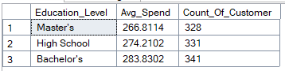

2. Analyze Purchase Intent vs. Income
This query helps you find your "ideal" customer profile.
select Income_Level,Purchase_Intent,COUNT(*) as transaction_count,round(avg(Purchase_Amount),2) as Avg_Value from dbo.[Ecommerce_Consumer_Behavior_Analysis_Data after data cleaning] group by Income_Level,Purchase_Intent order by Income_Level,avg(Purchase_Amount)
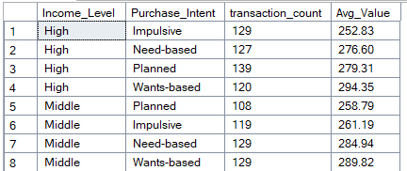

select SUM(Purchase_Amount) as Sum_Purchase_Amount, count(Distinct Customer_ID) as Total_Customers, avg(Customer_Satisfaction) as Avg_Customer_Satisfaction, avg(Return_Rate) as Avg_Return_Rate, Avg(Time_Spent_On_Product_Research_hours) as Avg_Time_Spent_On_Product_Research_hours from dbo.[Ecommerce_Consumer_Behavior_Analysis_Data after data cleaning]

select Avg(Purchase_Amount) As Avg_Purchaase_Amount,Education_Level
from dbo.[Ecommerce_Consumer_Behavior_Analysis_Data after data cleaning] group by Education_Level

select Avg(Purchase_Amount) As Avg_Purchaase_Amount,Marital_Status
from dbo.[Ecommerce_Consumer_Behavior_Analysis_Data after data cleaning] group by Marital_Status

select Avg(Purchase_Amount) As Avg_Purchaase_Amount,Age_Group
from dbo.[Ecommerce_Consumer_Behavior_Analysis_Data after data cleaning] group by Age_Group
